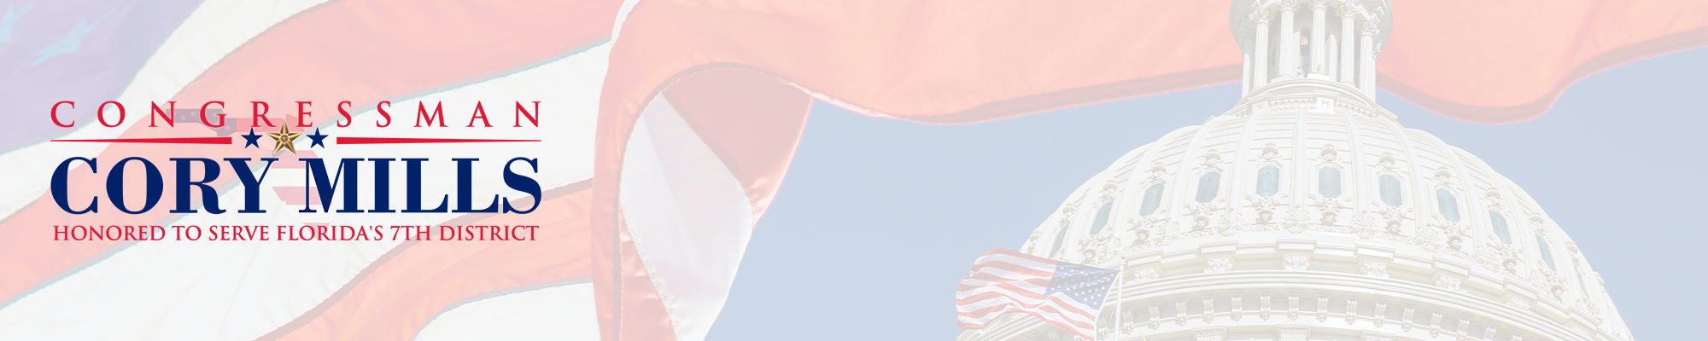
[PRELIM] FY 2027 Community Project Funding Information
Subcommittee on Energy and Water
CPF applications for certain accounts require additional information.
If the account from which you are requesting funding has a bolded prompt(s), please paste the prompt(s) and your response into the text box for question 37 of the CPF Request Form. Alternatively, you may save in a PDF and email to FL07CPFRequests@mail.house.gov.
The full FY2027 CPF Request Form is accessible here.
ACCOUNT-SPECIFIC QUESTIONS AND INFORMATION
The Energy and Water Subcommittee is reviewing community project requests ONLY in the categories listed below. Project requests that do not fit into one of these categories will not be eligible for community project funding.
- Army Corps of Engineers (Civil Works)
  - Investigations
  - Construction
  - Mississippi River and Tributaries
  - Operation and Maintenance
- Department of the Interior/Bureau of Reclamation
  - Water and Related Resources
Army Corps of Engineers (Civil Works)
- Is this project considered a ‘new start’ by the agency?
- Please indicate if this is a Corps request for a Continuing Authorities Program (CAP) project.
- If making a Corps request, please provide the name of the Corps Division where the project is located. If it is not a Corps request, write N/A.
- Please provide the name of the Corps District where the project is located.
Department of the Interior- Bureau of Reclamation
- If making a Reclamation request, please provide the name of the Reclamation Region where the project is located.

