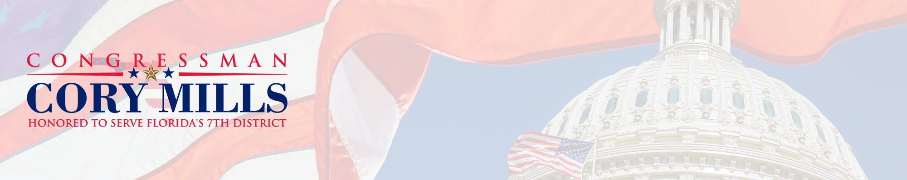
[PRELIM] FY 2027 Community Project Funding Information
Subcommittee on Interior
CPF applications for certain accounts require additional information. This document provides information on the accounts eligible for CPF applications within this subcommittee.
If the account from which you are requesting funding has a bolded prompt(s), please paste the prompt(s) and your response into the text box for question 37 of the CPF Request Form. Alternatively, you may save in a PDF and email to FL07CPFRequests@mail.house.gov.
The full FY2027 CPF Request Form is accessible here.
ACCOUNT-SPECIFIC QUESTIONS AND INFORMATION
The Interior, Environment, and Related Agencies Subcommittee is reviewing community project requests ONLY in the categories listed below. Project requests that do not fit into one of these categories will not be eligible for community project funding.
- Environmental Protection Agency
  - STAG—Clean Water State Revolving Fund
  - STAG—Drinking Water State Revolving Fund
Environmental Protection Agency -- State and Tribal Assistance Grants
The vast majority of requests made to the Interior Subcommittee are for STAG infrastructure grants. These grants fund local wastewater and drinking water infrastructure projects. This includes construction of and modifications to municipal sewage treatment plants and drinking water treatment plants. Similar to past practice, the Committee will be limiting STAG infrastructure grants only to projects that are publicly owned or owned by a non-profit entity and that are otherwise eligible for the funding from that state’s Clean Water or Drinking Water State Revolving Funds (SRF) loan programs. Privately-owned projects are NOT eligible for infrastructure grants, even if they are otherwise eligible for assistance under a SRF program. The Committee will look favorably upon requests for projects that are listed on a state’s most recent Intended Use Plan.
There is a minimum 20% cost share requirement for any portion of a project funded through a STAG infrastructure grant. For example, a $1 million project could receive a maximum of $800,000 from the federal government, with the remaining $200,000 the responsibility of the grantee. In almost all cases, other federal funds cannot be used to meet this 20% cost share. Ability to fund the 20% cost share is required before EPA can award a STAG grant. Please note that only the non-federal portion of assistance provided by a SRF can be applied towards a project’s matching requirement.
STAG projects have very specific eligibility requirements, and the Committee will not consider projects that do not meet those requirements. Please review the charts outlining examples for eligible and non-eligible STAG projects through the Interior Subcommittee guidance document on https://appropriations.house.gov/appropriations-requests.
- Please indicate whether this is a Clean Water SRF project or a Drinking Water SRF project.
- Does the project have (or expect to have within 12 months) its 20 percent matching fund requirement?
- Is the project on your state’s most recently finalized Clean Water/Drinking Water State Revolving Fund Intended Use Plan? Please provide documentation or link to online list.
- Has the project received federal funds previously? If so, please describe amounts, sources, and fiscal years.
- Given the Federal nexus requirement, does the project help meet or maintain Clean Water Act/Safe Drinking Water Act standards? If so, please describe.

